The 20th Annual Conference of the Inter-American Network on Government Procurement (INGP) invites a strategic reflection on the role of public procurement in responding to the region’s major challenges. Under the theme “Public Procurement as a Driver of State Coordination and Interconnection,” the Conference will explore how procurement systems can help strengthen institutional coordination, connect different levels of government, mobilize market capabilities, and generate greater public value.

The technical agenda will move beyond a purely operational understanding of public procurement and present it as a strategic tool to strengthen the State’s capacity to respond, stimulate economic activity, reduce territorial gaps, and build systems that are more reliable, intelligent, and ready for the future. The panels will explore key issues including economic security, supply chain resilience, local development, artificial intelligence, integrity, fiscal sustainability, and the evolution of regulatory frameworks.

In this context, the INGP reaffirms its role as a hemispheric platform for cooperation, supporting institutional strengthening, the modernization of public procurement systems, and the development of integrity-driven, resilient, and results-oriented procurement systems. Through this forum, countries will have the opportunity to exchange experiences, best practices, and capabilities, helping them to anticipate risks, respond to emerging demands, and move towards a more strategic, coordinated, and transformative approach to public procurement.

This conference brings together public procurement leaders from more than 30 OAS member countries and INGP observer members, as well as experts and key stakeholders from the region, to address the main challenges and opportunities in the field of government procurement. Through the exchange of experiences and best practices, participants will explore innovative strategies to strengthen the security, trust, and efficiency of procurement systems, as well as to optimize the use of public resources and expand the impact of public policies. Through this collective effort, the INGP reaffirms its commitment to contributing to the transformation of public procurement as a strategic tool for generating public value and building fairer, more transparent and resilient societies.

ORGANIZERS:


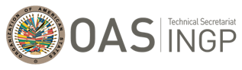
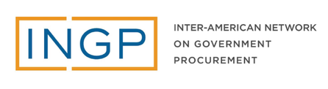

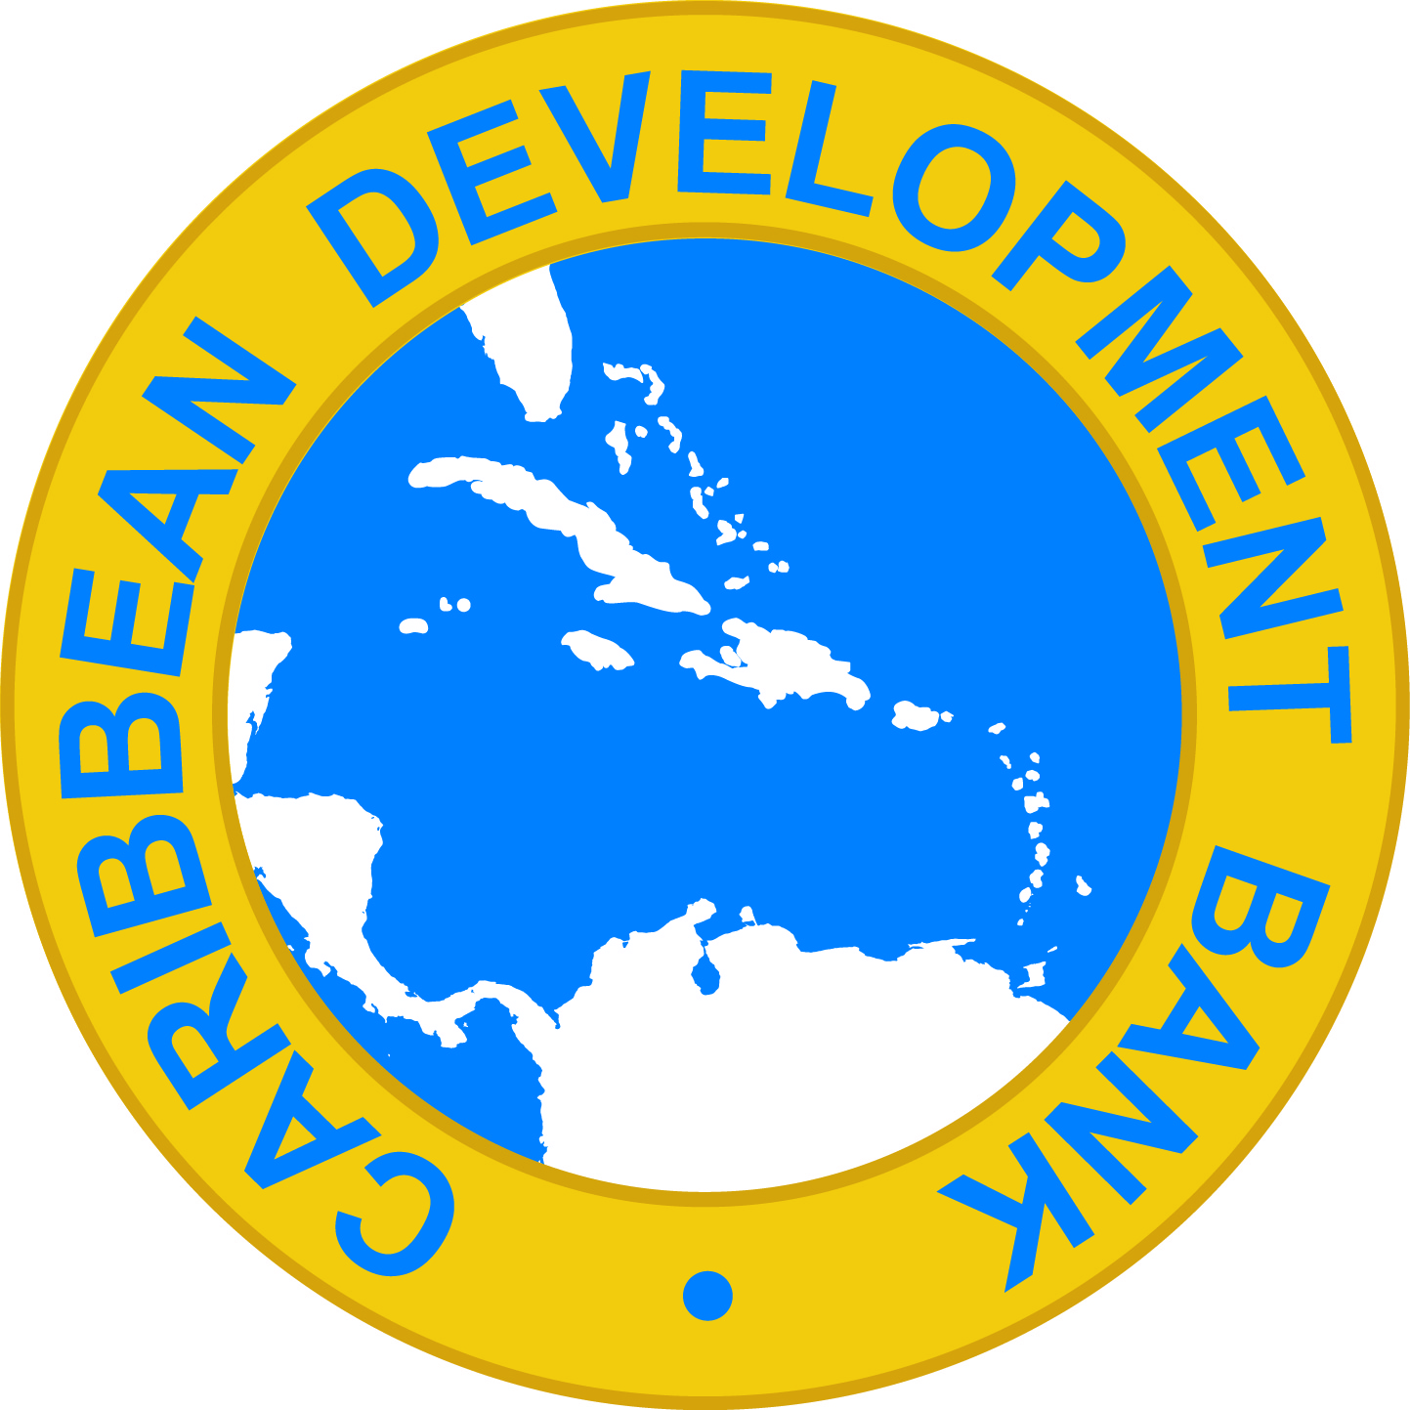


SPONSORS AND PARTNERS:

20th ANNUAL CONFERENCE OF THE INTER-AMERICAN NETWORK ON GOVERNMENT PROCUREMENT (INGP)

DAY 1 - INGP Public Sessions
Wednesday, August 12, 2026

7:30 – 9:00: PARTICIPANTS REGISTRATION
9:00–9:30: OPENING CEREMONY

9:00 – 9:10. Opening Remarks.
9:10 – 9:15. Alejandro Encinas Nájera, Undersecretary for Good Governance, Secretariat for Anti-Corruption and Good Governance, Federal Government, Mexico.
9:15 – 9:20. Juan Agustín Encina, INGP President 2026–2028 – National Director of Public Procurement, Paraguay.
9:20 – 9:25. Helena Fonseca, Principal Specialist, Public Procurement Program, Organization of American States / Technical Secretary, INGP.
9:25 – 9:30. Germán Zappani, Chief of Operations, Mexico Country Office, Inter-American Development Bank (IDB) – Mexico.
9:30 – 9:35. Naomi Akoy-Bouguenon, Acting Division Chief, Procurement Policy Division, Caribbean Development Bank (CDB).
9:35–9:40. Samuel Alejandro García Sepúlveda, Governor, State of Nuevo Leon, Mexico

9:40 – 10:00: KEYNOTE ADDRESS – “Geostrategy, Competitiveness, and Economic Security: The New Context of Public Procurement”

This lecture will examine how geopolitical tensions, shifting supply chains, technological transformation, and competition in strategic sectors are redefining the role of public procurement. In this context, the State’s purchasing power becomes a key tool for strengthening competitiveness, reducing vulnerabilities, and enhancing economic security in the Americas.

- José María Jimeno Feliú, Public Procurement Observatory, Spain.
10:00–10:20 COFFEE BREAK

10:20 – 11:40: PANEL DISCUSSION - GOVERNANCE AND COORDINATION ACROSS THE STATE:
How can the State strengthen its capacity to act in a more coordinated, coherent, and effective manner?

Among the major challenges faced by the region, the availability of resources is only one part of the equation. The central challenge lies in the capacity of governments to bring together institutions, different levels of government, and territorial capacities around shared priorities. Institutional fragmentation leads to duplication, fragmented responses, and loss of efficiency in the implementation of public policies. In response to these challenges, this panel will examine how public procurement can be consolidated as a strategic infrastructure for government coordination, capable of strengthening multilevel governance, streamlining public demand, and expanding implementation capacity with greater coherence, efficiency, and impact.

Moderator: Ana Cristina Calderon, Senior Fiscal Specialist, IDB

- Panelist 1: Juan Agustín Encina, National Director of Public Procurement, Paraguay.
- Panelist 2: Irais Barreto, Head of the Social Participation and Shared Responsibility Unit, Undersecretariat of Good Governance, Federal Government of Mexico.
- Panelist 3: Isis Burguez, Director of the State Procurement Regulatory Agency (ARCE), Government of Uruguay.
- Panelist 4: Adriano Dutra Carrijo, General Coordinator of Standards at the Directorate of Standards and Logistics Systems of SEGES, Brazil. Express Procurement System (SICX).
Q&A (10 min)
11:40 – 12:40: PANEL DISCUSSION: ECONOMIC SECURITY AND RESILIENCE OF PUBLIC SUPPLY CHAINS: What capacities does the State need to anticipate risks, secure critical supplies, and respond to crises?

Recent crises, geopolitical conflicts, disruptions in global supply chains, and growing competition for strategic goods have shown that public procurement can no longer be understood solely from an operational perspective. In an environment marked by uncertainty, price volatility, logistical constraints, and risks affecting access to critical inputs, governments face the challenge of anticipating vulnerabilities and strengthening their response capacity. This panel will explore how public procurement can contribute to economic security, the continuity of essential services, and productive resilience through strategies that allow for supplier diversification, the strengthening of supply chains, the development of capabilities in critical sectors, and the improvement of institutional preparedness for emergencies, disruptions or conflicts.

Moderator: Alice Castro, Procurement Specialist, Caribbean Development Bank (CDB)
- Panelist 1: Ministry of Economy, Government of Ukraine.
- Panelist 2: Caribbean Experience, Caribbean Disaster Emergency Management Agency (CDEMA).
- Panelist 3:
12:40–13:40 PM: LUNCH

13:40 – 13:50: INFORMATIVE CAPSULE

- Carlos Ortiz, Public Procurement Expert. What are the critical decisions needed to generate maximum value through public procurement?
13:50 PM – 15:10 PANEL DISCUSSION: VALUE FOR MONEY AND CREATING PUBLIC VALUE
How do public procurement decisions maximize value?

Public procurement is one of the main tools through which resources are translated into results. However, in a context of growing fiscal pressure, the question is no longer only how much a purchase costs, but how much value it generates for society. This panel will analyze how governments are moving from approaches focused on compliance and lowest-price toward models that integrate performance, quality, life-cycle costs, and impact, ultimately enabling a better use of public resources and generating greater for citizens.

Moderator: Carlos Ortiz, Public Procurement Expert.

- Panelist 1: Jean-Jacques Verdeaux, Procurement Practice Manager for the Latin America and Caribbean Region of the World Bank.
- Panelist 2: Jovell Barrett, Head of Public Procurement, Government of Jamaica.
- Panelist 3: TBD, General Directorate of Procurement (DGA), Government of Peru.

Q&A (10 min)
15:10 – 15:25: INSIGHT CAPSULE – IDB Procure + Reform

- Freddy Andara, Senior Procurement Specialist, Financial Management and Procurement Division, Inter-American Development Bank (IDB).
15:25–15:45 COFFEE BREAK

15:45 – 16:05: KEYNOTE ADDRESS – More Participation Does Not Necessarily Mean Greater Competition

- Gian Luigi Albano, Researcher of the Utrecht University Centre for Public Procurement (UUCePP) and Adjunct Professor of Economics at LUISS Guido Carli University in Rome.
16:05–17:05: PANEL DISCUSSION: ECONOMIC DEVELOPMENT AND COMPETITIVENESS:
How can public demand mobilize market capabilities and drive innovation?

Public procurement does not only respond to institutional needs; it can also shape markets, stimulate competition, and activate innovation capacities. This panel will analyze how governments can strategically use public demand to promote new solutions, strengthen suppliers, energize economic sectors, and improve market’s capacity to respond to increasingly complex public challenges.

Moderator: Helena Fonseca, Senior Specialist, Public Procurement Program, OAS

- Panelist 1: Ximena Jacinta García Ramírez, Deputy Director of Supply, PEMEX, Mexico.
- Panelist 2: Ms. Hwayeon Jeong, Senior Deputy Director, Procurement Management Division, Public Procurement Service-PPS, Government of South Korea.
- Panelist 3: Yesenia Ledezma, Director of Public Procurement, Ministry of Finance, Government of Costa Rica.

Q&A (10 min)

17:05– 17:25: INSIGHT CAPSULE

- Sandra Sinde, Expert in Public Procurement of Innovation (PPI), LASINDE (10 min).
- Liliana Ortíz, Director of the Procurement Unit, National Electricity Administration (ANDE), Government of Paraguay – Pilot Implementation Case in Public Procurement of Innovation (10 min).
17:25: CLOSING OF DAY ONE

DAY 2 - INGP Public Sessions
Thursday, August 13, 2026

20th ANNUAL CONFERENCE OF THE INTER-AMERICAN NETWORK ON GOVERNMENT PROCUREMENT (INGP)

9:00 – 10:20: PANEL DISCUSSION – SUSTAINABLE DEVELOPMENT AND TERRITORIAL MANAGEMENT: How can national procurement strategies be adapted to the capacities and needs of local communities?

Development gaps across territories remain one of the most pressing challenges in the Americas. Public procurement can help bridge these disparities by connecting public needs with local capabilities, strengthening regional economies, and expanding opportunities for local suppliers. This panel will explore how procurement can foster environmental, social, and territorial development through place-based solutions and collaboration among communities, businesses, and governments to unlock the unique potential of each territory.

Moderator: Ana Fernanda Hierro, Technical Secretary of the Nuevo León Council. (TBC)

- Panelist 1: Gloria Morales, Secretary of Administration, State of Nuevo León, Mexico
- Panelist 2: Genoveva Ferrero, Secretary of General Administration and Budget of the Judiciary of the Autonomous City of Buenos Aires, Argentina.
- Panelist 3: Carlos Pimentel, Director General of Procurement, Dominican Republic.
- Panelist 4: Álvaro Luna, Director, Eco-Advance Regional Project, GIZ

Q&A (10 min)

10:20– 10:40: INSIGHT CAPSULE - Belém Declaration on Sustainable Public Procurement

- Geórgia Mota, General Coordinator for International Affairs, SEGES, Government of Brazil.

10:40–11:00 COFFEE BREAK

11:00– 11:20: KEYNOTE ADDRESS - “Digital Transformation as a tool for better collaboration with the private sector.”

- Oscar Hernández, Regional Project Manager for Latin America, Open Contracting Partnership (OCP).

11:20 – 12:20: PANEL DISCUSSION – INTEGRITY AND COMPLIANCE:
How to Build Public Procurement Systems Capable of Effectively Preventing, Detecting, and Managing Risks

As public procurement systems become increasingly complex, governments need to move beyond approaches focused only on regulatory compliance and towards governance models based on prevention, smart risk management, and trust-building. This panel will analyze how compliance, ethics, technology, and institutional leadership can be integrated to strengthen the integrity of public markets and protect the legitimacy of government action.

Moderator: Jacobo Pastor García, Senior Specialist in Integrity and Public Procurement, OECD.

- Panelist 1: Begoña Ballvé, Expert in Compliance and Public Procurement, Spain.
- Panelist 2: Esteban Vega de la O, Director of the Costa Rican Social Security Fund (CCSS), Government of Costa Rica.
- Panelist 3: Beverly Khan, Head of the Office of Procurement Regulation (OPR), Government of Trinidad and Tobago.

Q&A (10 min)
12:20–13:20: LUNCH

13:20 – 13:40: KEYNOTE ADDRESS - “Responsible AI Procurement, the Human Factor and the Future of Trust”

- Dr. Gisele Waters, Education Director and Co-Founder of the AI Procurement Lab (AIPL) and Adjunct Professor at Nova Southeastern University’s Fischler College of Education & School of Criminal Justice.

13:40 – 15:00 PM: PANEL DISCUSSION: ARTIFICIAL INTELLIGENCE AND NEW PUBLIC GOVERNANCE: How can artificial intelligence transform the way the government plans, makes decisions, and procures?

Artificial Intelligence (AI) is reshaping how governments anticipate needs, analyze information, manage risks, and make timely, strategic decisions. In public procurement, its value goes well beyond automation: AI can support better planning, more informed decision-making, enhance traceability, and the development of smarter, more transparent, and adaptive procurement systems. This panel will analyze how to integrate artificial intelligence into public procurement systems in an ethical, integrity-driven, and responsible manner, while strengthening data governance, institutional trust, risk prevention, and the government’s ability to respond to increasingly complex challenges.

Moderator: Alejandro Ravizé, Head of Innovation in Public Management, Secretariat for Anti-Corruption and Good Governance, Mexico (TBC).

- Panelist 1: Darti Malaj, Public Procurement Expert, Public Procurement Agency, Government of Albania: Diella.
- Panelist 2: General Services Administration (GSA), Government of the United States: AI for market analysis and risk management in the supply chain. (TBC)
- Panelist 3: Cristian Céspedes Viñuela, Acting Director, ChileCompra: Risk prevention in the identification of ultimate beneficiaries.
- Panelist 4: Roberto Reta, Public Procurement Director, Mendoza, Argentina.

Q&A (10 min)

15:00– 15:10: INSIGHT CAPSULE -

- GEP – Intelligence Drives Innovation –

15:10 – 15:30 COFFEE BREAK

15:30 – 15:50: KEYNOTE ADDRESS: What Institutional, Technological, and Management Capacities Does the Region Need to Generate Sustainable Public Value?

- Enrique Díaz, Director of the Ibero-American Public Procurement Network (REDICOP).

15:50 – 16:30: Presentation of the winning initiatives / “2026 INGP Public Procurement Innovation Award”

- Hugo Inga, Public Management Expert, INGP/OAS Technical Secretariat Team.

16:30: CLOSING OF THE 20TH ANNUAL RICG CONFERENCE

- Gloria Morales, Secretary of Administration, Nuevo León.
- Agustín Encina, President, Inter-American Network on Government Procurement (INGP), Paraguay.

DAY 3 – INGP Private Session
Friday, August 14, 2026

9:00–9:15 a.m.: Opening

- Irais Barreto, Head of the Social Participation and Shared Responsibility Unit, Undersecretariat of Good Governance, Federal Government of Mexico.
- Agustín Encina, INGP President 2026–2028 / Paraguay
- Helena Fonseca, Technical Secretary of the INGP, OAS.

9:15–9:30 a.m.: Presentation of the OAS Management Report on INGP Activities 2025–2026

- Hugo Inga, Public Management Expert, INGP Technical Secretariat Team/OAS.

9:30–10:15 a.m.: Presentation of initiatives by INGP supporting organizations

- Freddy Andara, Senior Procurement Specialist, IDB.
- Ana Cristina Calderón, Senior Fiscal Specialist, IDB.
- Naomi Akoy-Bouguenon, Acting Head of Procurement, CDB.

10:15 AM–12:00 PM: Subregional Meetings and Coffee Break

12:00 PM - 1:00 PM: Lunch
1:00–3:00 PM: Country discussions on priorities and initiatives.
3:00 PM: Closing

