
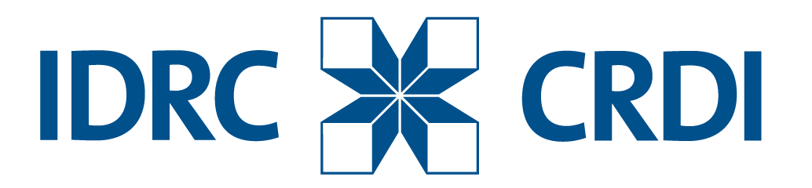
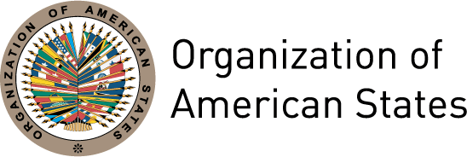


COUNTRY REPORT
TENTH ANNUAL CONFERENCE OF THE INGP
October 27th to 30th, 2014. Asuncion, Paraguay

Bahamas
Ministry of Finance

Name of the Director of Government Procurement: Mr. John Rolle

- Short Description – Principal characteristics of the procurement system.

The present system is manual base and decentralize, i.e. Tenders Board meeting, approvals by the Ministry of Finance and award of contracts.

The system is also subject to Thresholds in procuring goods and services. A brief review of the process is captured below.
- Government Agencies are authorized to purchase goods and services at amounts ≤$50,000.00
- When the Procurement is >$50,000 and ≤$250,000.00, approval from the Tenders Board is required.
- Procurement of Goods and Services > than $250,000.00 require approval from the Cabinet.

- Accomplishments -2013-2014.

- Amendment to the Financial Administration and Audit (Amendment) Bill 2013 – Public Procurement Unit

- Under the ICT4GP Grant PWC was awarded the contract for the Consultancy Services for the modernization of the Government’s procurement systems to better align those systems with regional and international standards, and to promote the participation of Micro, Small and Medium Enterprises.

- As-Is process mapping and gap analysis was conducted

- Draft Report on TO-Be procurement function and governance framework

- Final Report – To Be process Mapping

- Design of supplier data, data scripts and data structure

- Procurement exercise has been conducted for the e-procurement and supply registry. 8 Firms submitted bids, 5 Firms were shortlisted. The shortlisted firms were invited to demonstrate their product.

- Awaiting – Award of contract – pending Tenders Board support and Cabinet’s approval

- Please indicate the role/contribution of the INGP in the previously mentioned accomplishments.

Our participation at the last INGP workshop has basically made it clear that much work in required in the area of Procurement in aligning country systems with international best practices.

As the Government is in the process seeking assistance from the IDB to reform its financial management system, a component in the operation will focus on, among other things, capacity building, legislative and regulatory reforms, and centralization of procurement to mitigate challenges in this key area of financing.

There is optimism that participating in the INGP seminars will certainly add value in advancing the proposed procurement project with the IDB.

- Goals -2014-2015.

- Implementation of software and training and workshops for the e-tendering and e-procurement system
- Invitation for vendors to registry online in the Supplier Registry
- Pilot Implementation Plan
- Training for members of the procurement function and key Government departments and agencies
- Validate the registry of suppliers
- Commence Implementation of proposed IDB Investment Project that include addressing procurement reform.

